
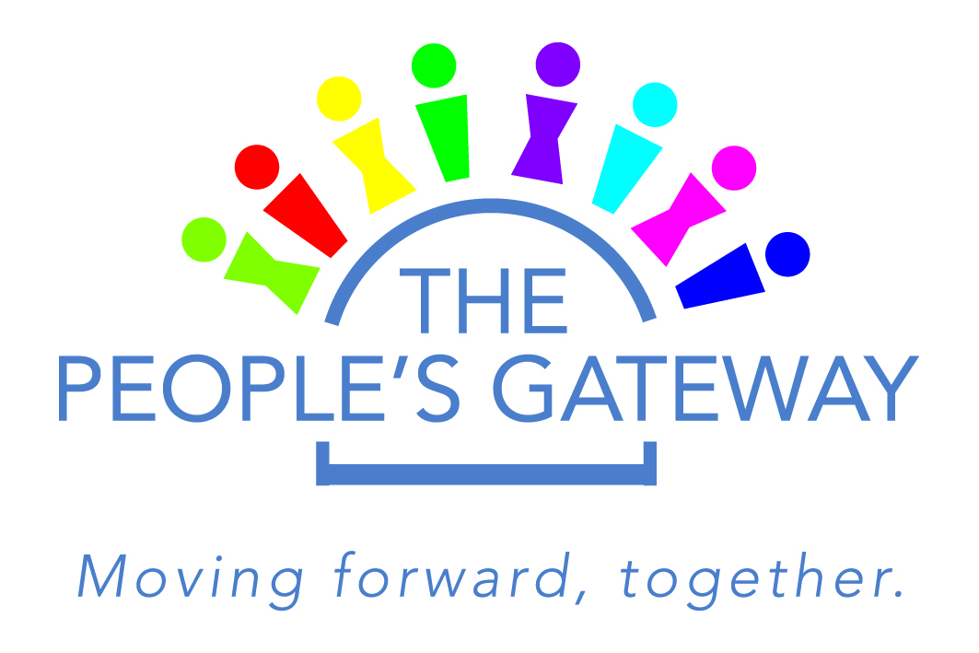

Job Title: Income Adviser

Salary: £26,500 (per annum)
Duration: 3 years (reviewed annually on performance)

Reports to: Chief Executive
Base: 17-19 Newhills Rd, Glasgow, G33 4HH
(also within local housing association offices)
Hours: 35 hrs

Overview

Connect Community Trust has operated the Peoples Gateway project over the past 6 years and it is an integral part of the organisation and our support to local people within Greater Easterhouse.

A key priority for Connect and our partner housing associations is to provide support to people through the current welfare reform. Growing indebtedness has meant increased demand for money and benefits advice services across our job club and community services.

As a result of this growing demand Connect has worked with local housing providers to provide direct money and benefits advice. Giving people the knowledge, tools and confidence to be able to resolve matters themselves or provide a gateway to specialist advice or other complementary services when further help is required.

Objectives of this newly formed income advice service:

- To work towards the alleviation of hardship and disadvantage by providing information, advice and assistance on money, benefits and related issues i.e fuel poverty
- To promote the financial wellbeing of residents
- To contribute to the development of strategies and interventions to reduce financial exclusion

- Main Duties & Responsibilities

- To provide advice and advocacy to clients in relation to welfare benefits and related issues.
- Promote and support financial wellbeing through the provision of money related information, advice and assistance in connection with Social Welfare Reform.
- To raise awareness of credit issues and options towards the prevention of over indebtedness.
- To provide advice and advocacy to clients in relation to the management of household and personal budgeting including addressing fuel poverty.
- To maintain up to date working knowledge of welfare benefits, financial inclusion and debt issues.
- To advise clients with multiple debt problems by establishing the total debt situation, maximising income and where appropriate, negotiating an affordable repayment programme on their behalf.
- To raise awareness and support learning of social welfare reform with communities and colleagues and other providers in statutory and voluntary settings.
- To undertake specialist advocacy work and provide representation in court as appropriate.
- Prepare and provide representation at benefit appeals and tribunals.
- To contribute to local and national policy and practice development, as required.
- To work with colleagues, other agencies and organisations to promote good practice in advice giving through the implementation of strategies.
- Establish effective networks in the community, support partnerships and support the development of financial inclusion initiatives.
- Make representations on behalf of clients to a variety of agencies.
- Representation on working groups/external panels as required.
- To share in the development of appropriate materials to promote information on Money Advice and Financial Inclusion Interventions.
- Provide training to colleagues and other advice providers (statutory and voluntary) on benefit issues, debt issues and welfare reform.
- To maintain full contact and case records and provide performance reports as requested.
- To maintain and report statistical information on levels of indebtedness.
- Ensure good practice in advice through the application of The Scottish National Standards for Information and Advice Providers.
- Any other duties as may be considered appropriate for this post.

- Knowledge and Skill Requirements

- HND level or relevant experience in the Advice Sector
- Experience of providing advice in welfare benefits
- Experience of appeals
- Up to date knowledge of Welfare Benefits issues.
- Extensive knowledge of and ability to interpret the legislative framework for social welfare.
- Has a broad practical understanding of the business activities of social welfare and the interdependencies across the service/services and agencies.
- Customer/client focussed with excellent consultation, negotiation, interpretation, interpersonal and communication (written, oral and listening) skills.
- Ability to work as part of a team or on own initiative.
- An ability to manage relationships with colleagues and service users.
- Ability to work under pressure in a changing environment.
- Experience of partnership working.
- Sound knowledge and experience of relevant software packages and computer literate.

Working knowledge of Social Welfare legislation/policy
- Ability to interpret primary and secondary legislation and guidance
- Challenging range and variety of complex professional work activities in a changing environment across services and multi agencies
- Ability to work to deadlines, ability to manage competing priorities, ability to work as part of a team, a flexible approach
- Fully conversant with the National Standards for Information and Advice Providers

- Working Environment

- The ability to work with vulnerable people and be sensitive to their needs.
- Flexibility and ability to prioritise workloads
- May be expected to work out-with normal office hours on occasion

